eCMS MANUAL

Duty Free Quota Approval

Department of Revenue and Customs
Ministry of Finance
Table of Contents
1. Introduction 3
2. Logging in as Custom Officer 3
3. Duty free User Registration Approval 3
3.1 Approver 3
3.2 Assign Role 4
4. Quota Approval 5
4.1 Search Duty Free Application 5
4.2 Verifier 5
4.3 Approver 6
5. Duty Free Warehouse Declaration Approval 9
5.1. Approve Declaration 9
5.2. Centralized Risk 9
5.3. Release 10
5.4. Warehouse Entry 11
6. Duty Free Sales for Non quota Holder 12
6.1. Approve Declaration 12
6.2. Payment 13
6.3. Valuation 14
6.4. Release 15
6.5. Warehouse Release 16
7. Duty Free Sales for Non quota Holder 19
7.1. Approve Declaration 19
7.2. Release 19
7.3. Warehouse Release 20
8. Duty Free Sales Airport 22
8.1. Approve Declaration 22
8.2. Release 23
8.3. Warehouse Release 24
9. Duty Free Consumption on Board 26
9.1. Approve Declaration 26
9.2. Release 26
9.3. Warehouse Release 27
10. Duty Free Sales on Board 29
10.1. Approve Declaration 29
10.2. Release 30
10.3. Warehouse Release 30

Introduction
CMS use the Duty Free module to approve the application that has been submitted by applicant.

Logging in as Custom Officer
- The user needs to log into eCMS using the url: www.ecms.gov.bt
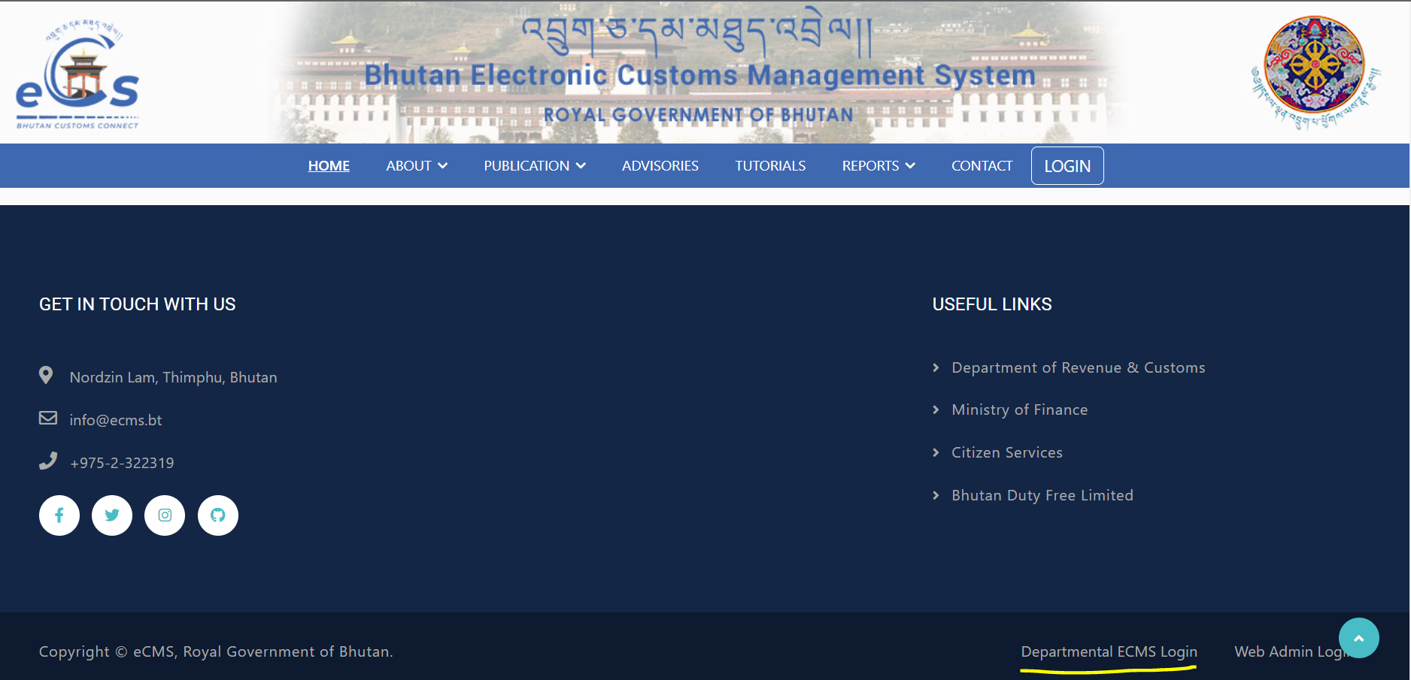
- Click on login menu and provide the required credentials to log in to the system:

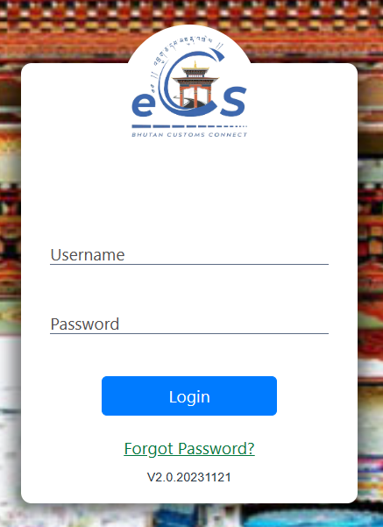

Duty free User Registration Approval
- Click on the menu Registration approval.

Approver
- Go to Registraion menu and click on “Approver”.
- Search for the application reference number if the number is known/ the Custom user will be doing there due diligent but working on the day-to-day application received.
- The Custom user will then validate the application under each menu to validate the detail submitted by the applicant.
- Once the review is completed the focal will have the option to do the following to the application:
- Approved: the recommended application via verifier is reviewed and approved
- Rejected: the application gets rejected due to certain reasons; the reason will be then provided in remarks.
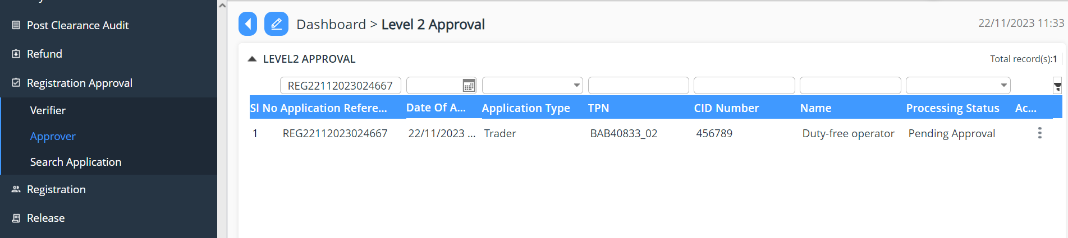
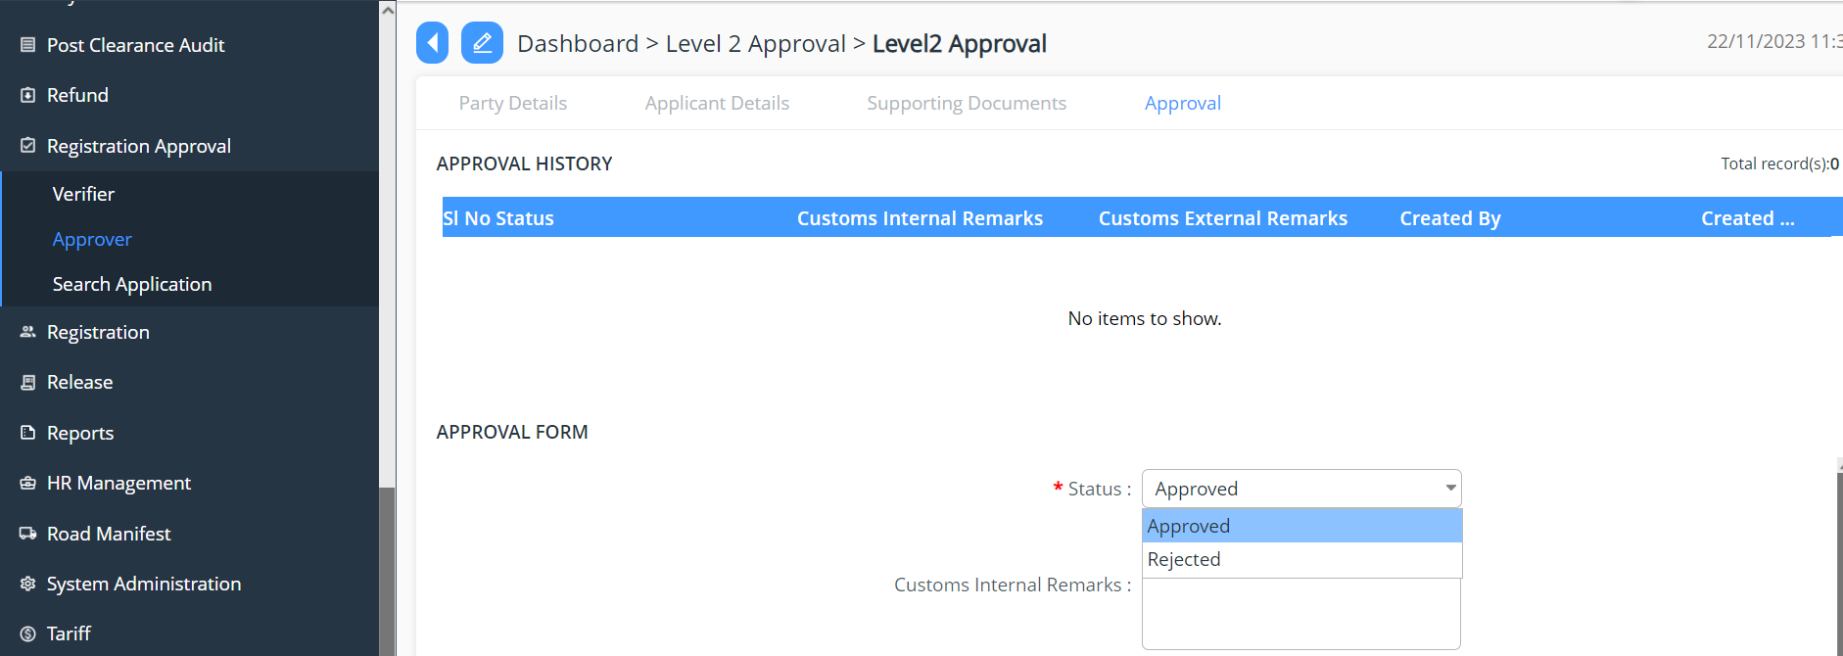

- Once approved the credentials are send to the concern applicant

Assign Role
- Click on to menu Registration
- Select the menu Front End User
- Select the user
- Add user role to that user by clicking on + button
- Select the Duty Free role and Save
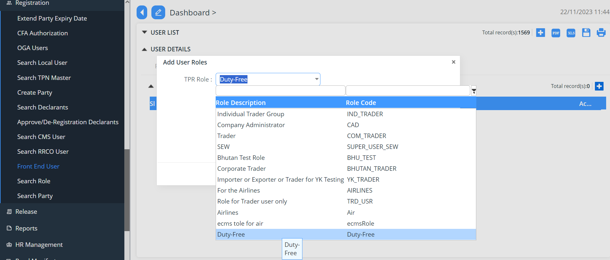

Quota Approval
- Click on the menu Duty Free

Search Duty Free Application
- Go to Duty Free menu and click on “Search Duty Free Application”.
- List of application that has been submitted and listed under the Custom user.
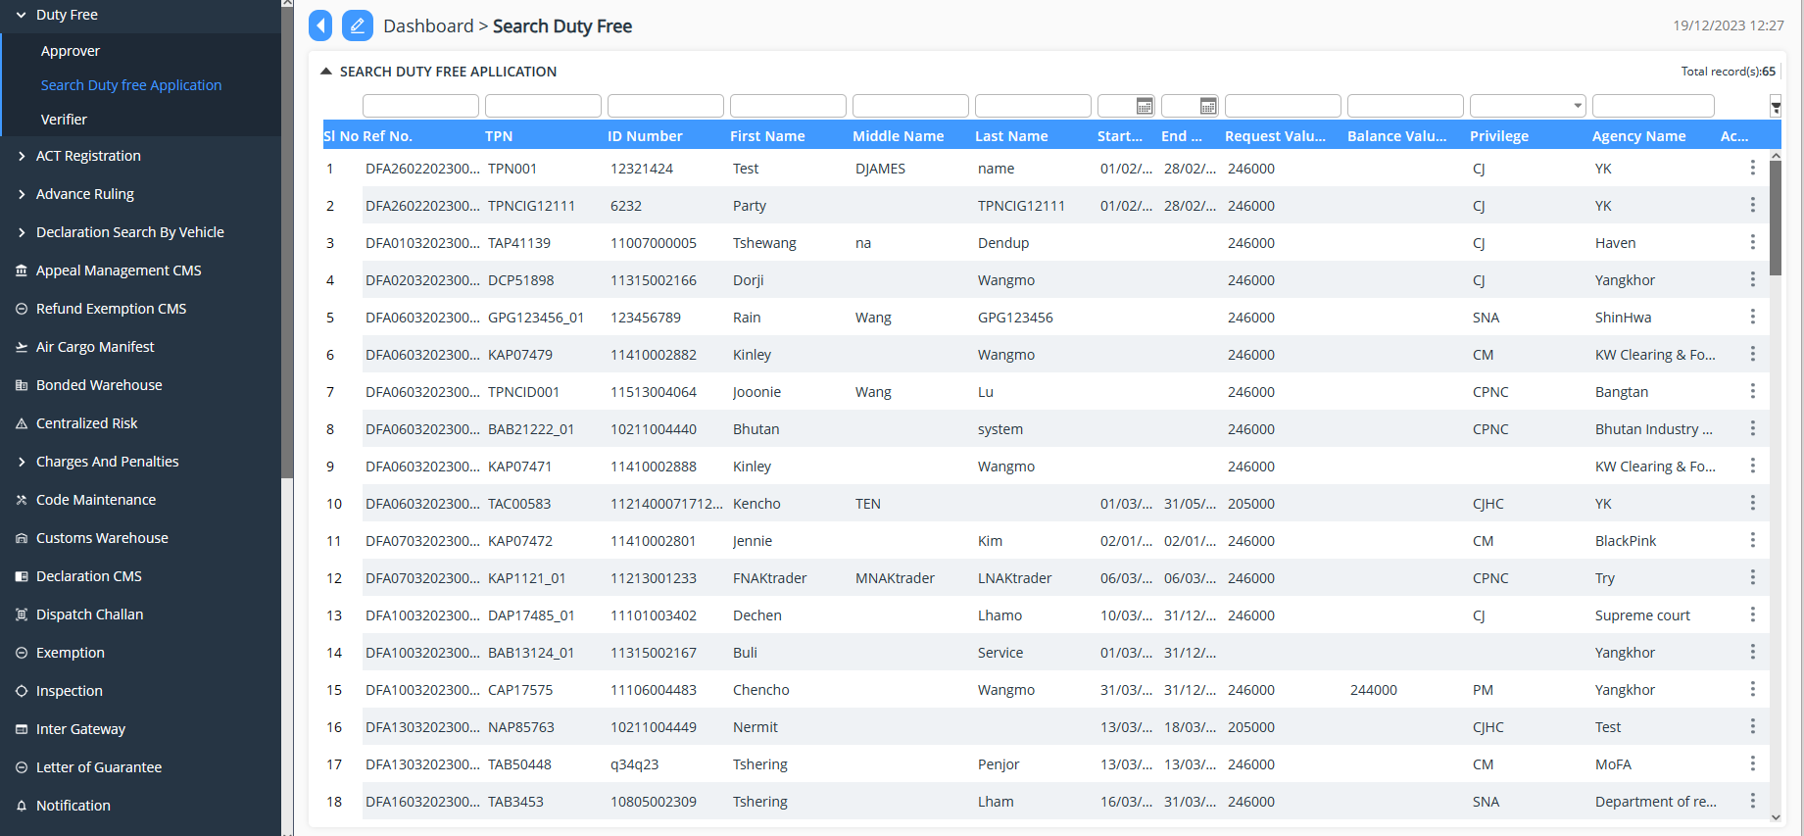

Verifier
- Go to Duty Free menu and click on “Verifier”.
- Search for the application reference number if the number is known/ the Custom user will be doing there due diligent but working on the day-to-day application received.
- The Custom user will then validate the application under each menu to validate the detail submitted by the applicant.
- Once the review is completed the focal will have the option to do the following to the application:

- Recommend Approval: the application is reviewed the application and then recommend for the approval to next level.

- Reject Application: the application gets rejected due to certain reasons; the reason will be then provided in remarks.
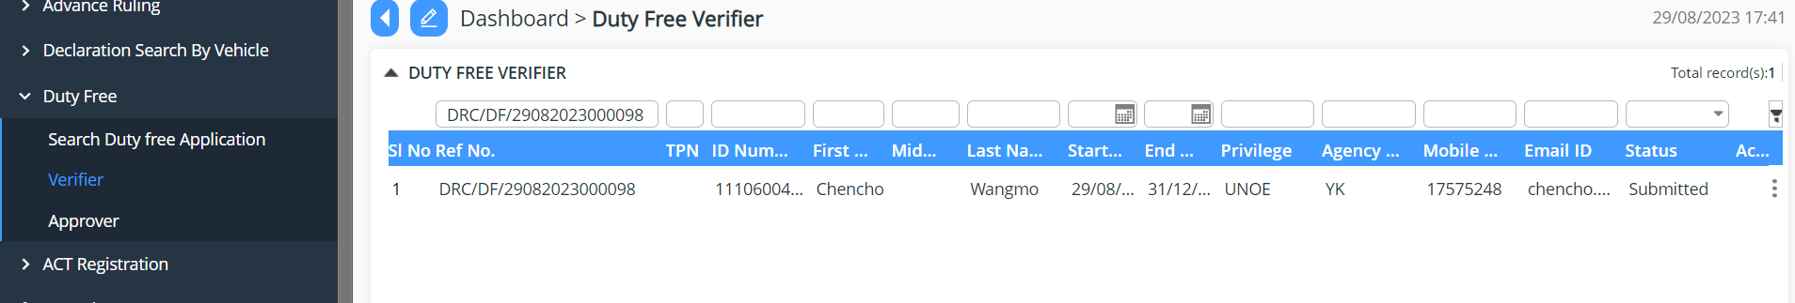

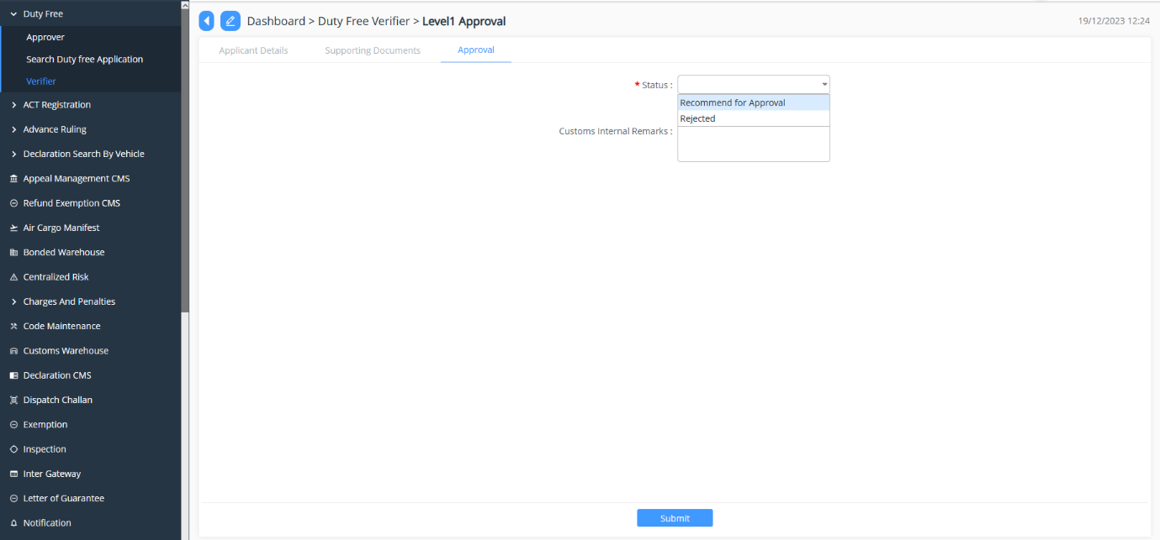

Approver
- Go to Duty Free menu and click on “Approver”.
- Search for the application reference number if the number is known/ the Custom user will be doing there due diligent but working on the day-to-day application received.
- The Custom user will then validate the application under each menu to validate the detail submitted by the applicant.
- Once the review is completed the focal will have the option to do the following to the application:
- Approved: the recommended application via verifier is reviewed and approved
- Rejected: the application gets rejected due to certain reasons; the reason will be then provided in remarks.
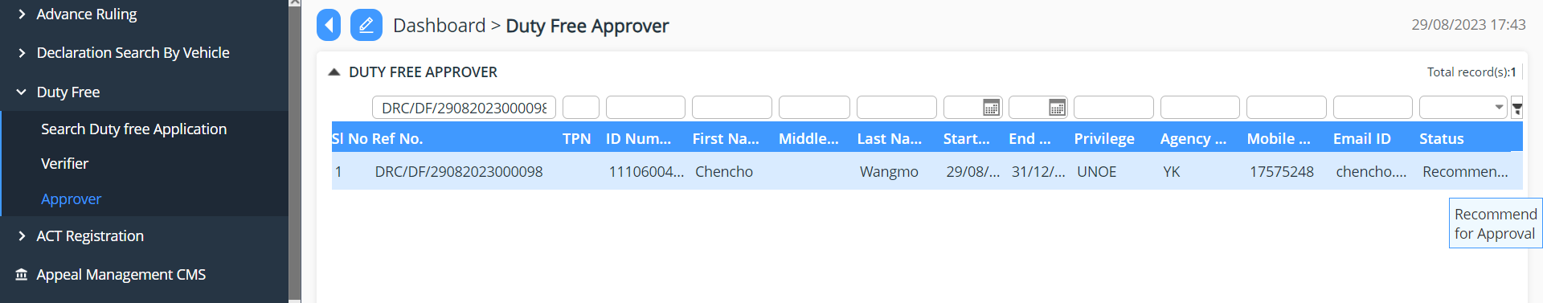
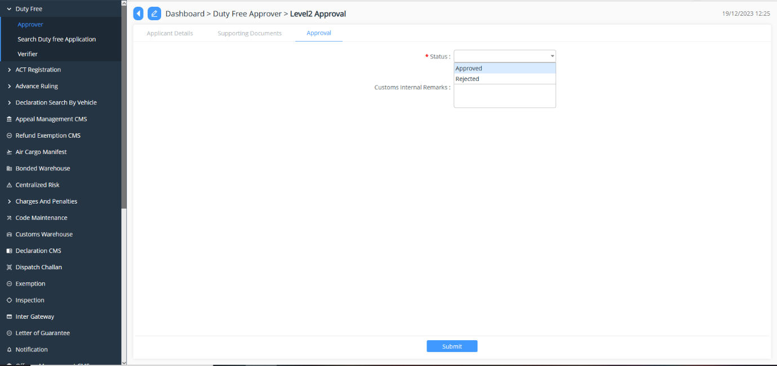

- On the application has been approved the concern application shall receive the letter of DF Membership as shown below:

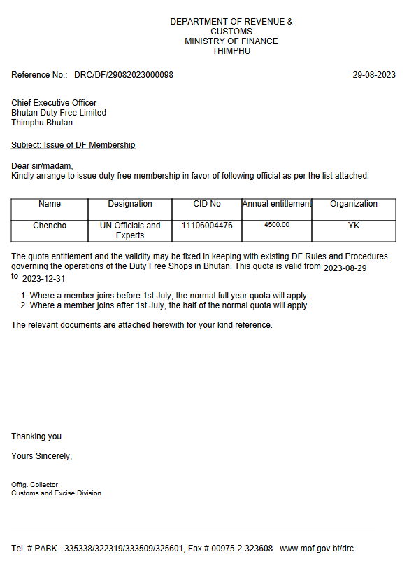

Duty Free Warehouse Declaration Approval

Approve Declaration

- Go to Declaration menu and click on “Approve Declaration”.
- Search for the declaration reference number if the number is known/ the Custom user will be doing there due diligent but working on the day-to-day application received.
- The Custom user will then validate the declaration under each menu to validate the detail submitted by the Duty Free user.
- Once the review is completed the focal will have the option to do the following to the declaration:

- Approve: the application is reviewed and approved
- Reject: the application gets rejected due to certain reasons; the reason will be then provided in remarks.
- Reject for amendment: due to certain missing details the application will be send back for amendment.
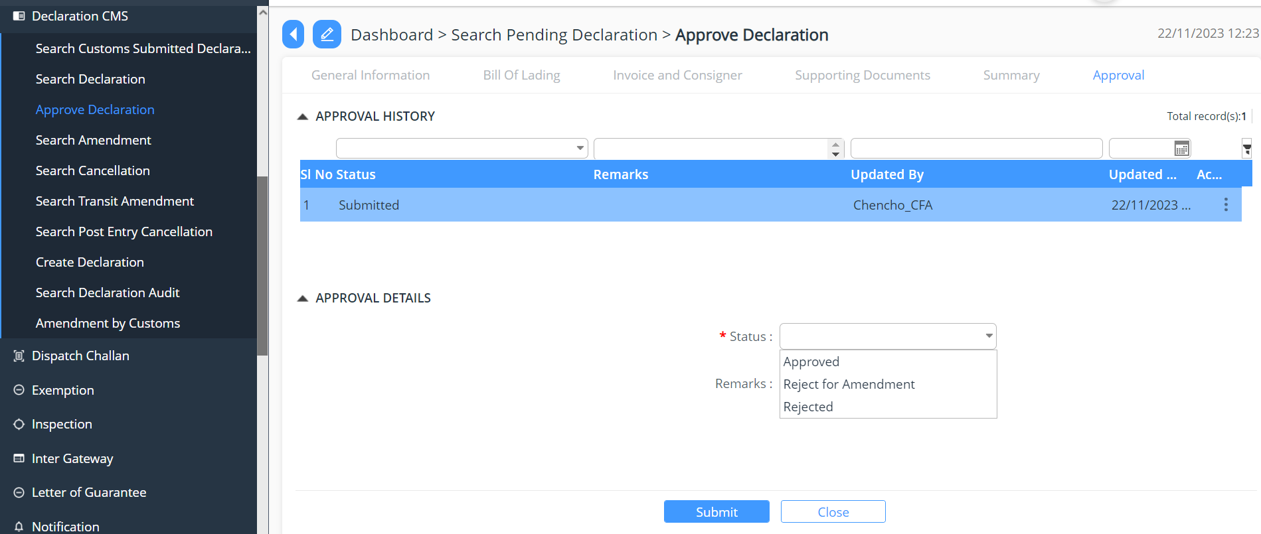

Centralized Risk
- Go to Centralized Risk
- Pending Risk Assessment
- Provide the risk assessment details
- Update the declaration
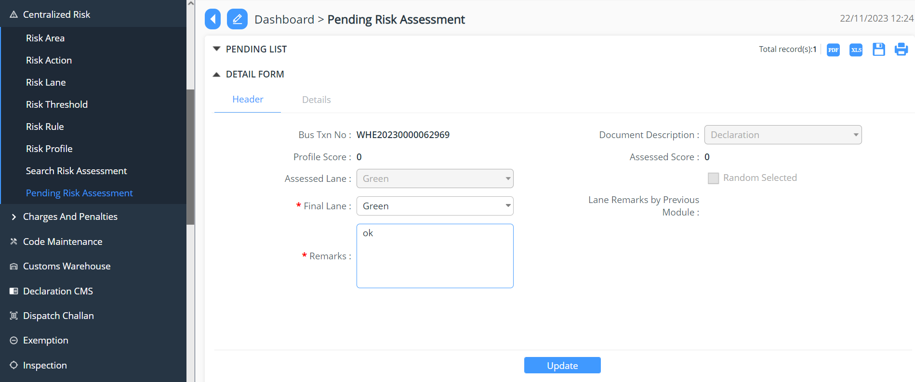

Release
- Go to Release
- Select the menu Release Order
- Select the declaration for release
- Choose the release order status from the drop down list
- Update the declaration
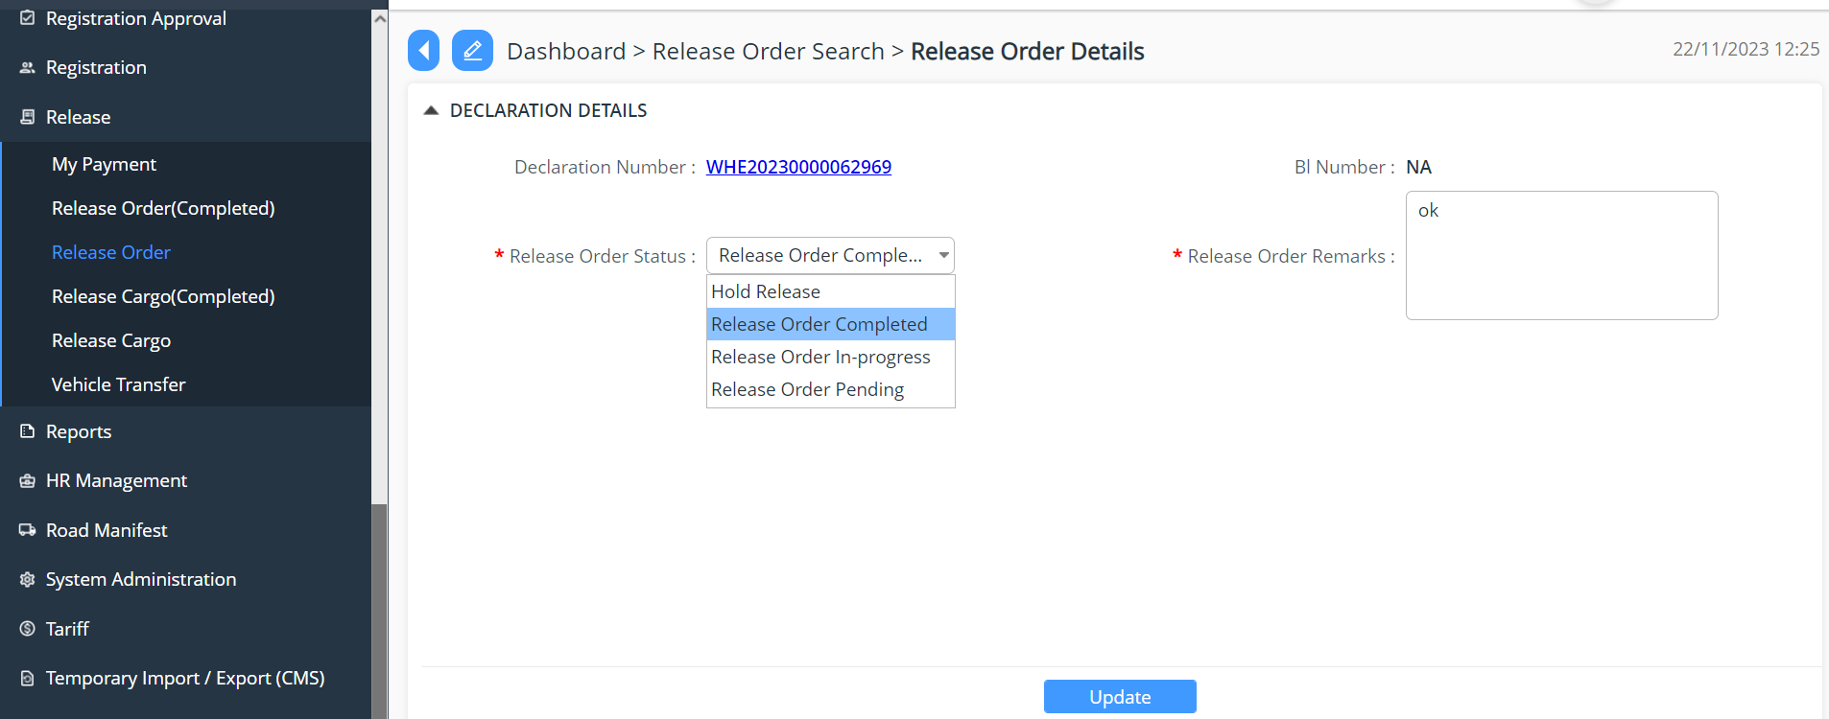

- Go to Release
- Select the menu Release Cargo
- Select the declaration for release
- Provide details for the following :
  - Vehicle number
  - Gross Weight
  - No of Packages
  - Choose the release cargo status from the drop down list
- Update the declaration
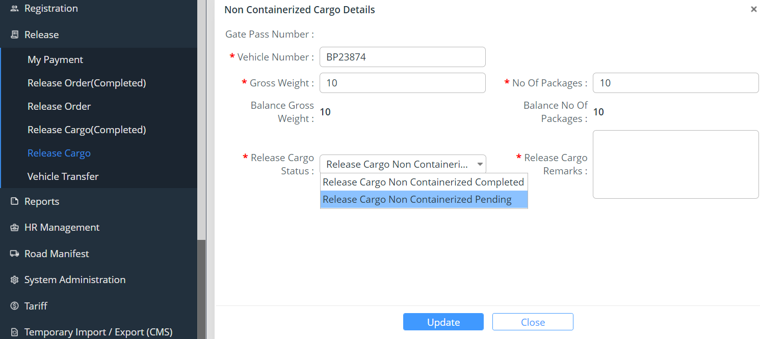

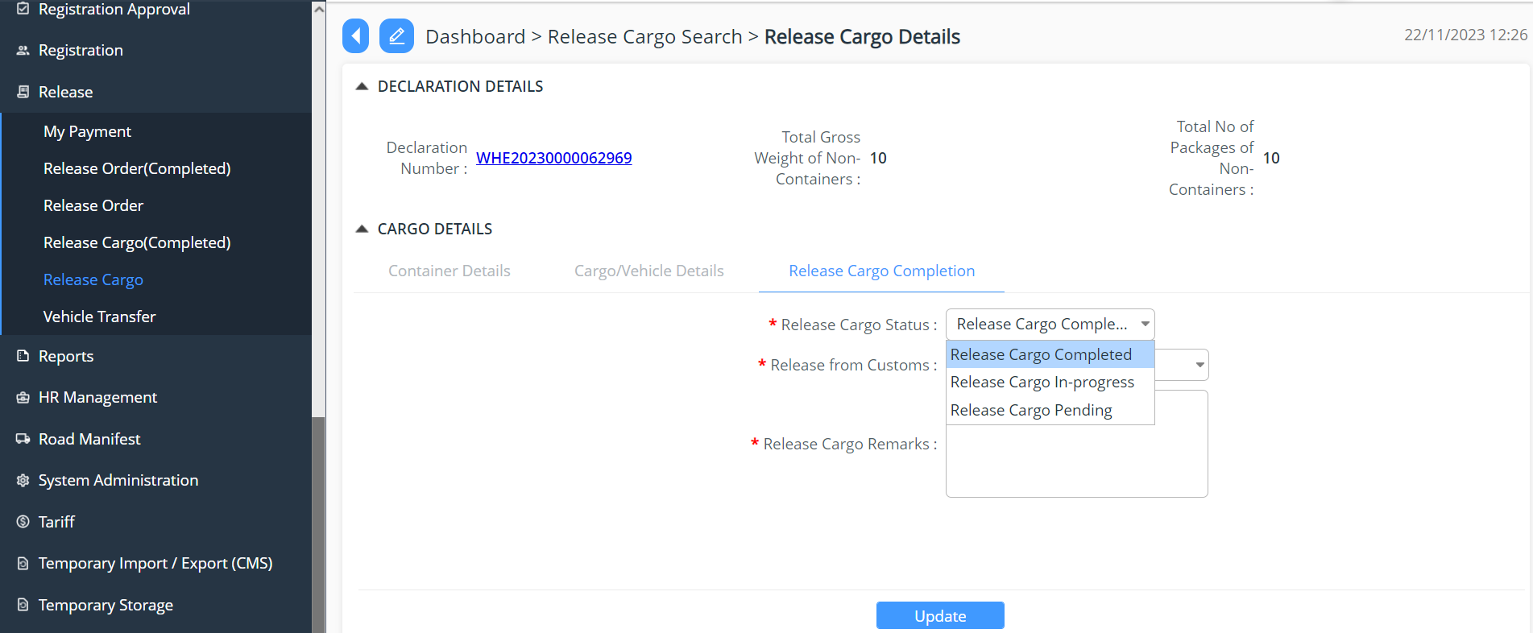

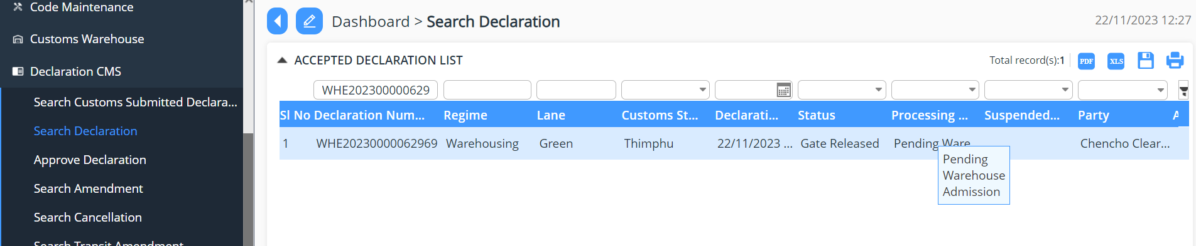

Warehouse Entry
- Login as Warehouse Operator
- Admit the goods as per the declaration

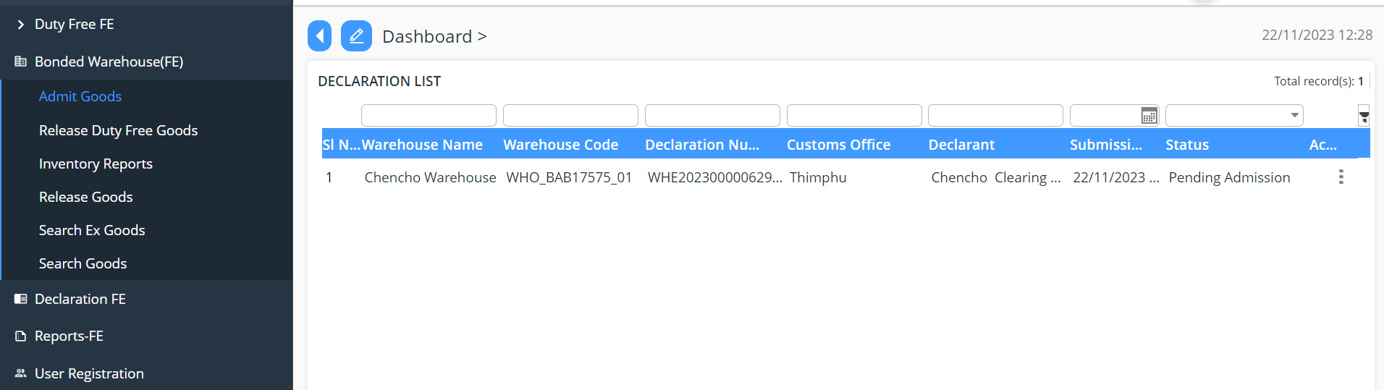

Warehouse Inventory provides the details of the goods in the warehouse
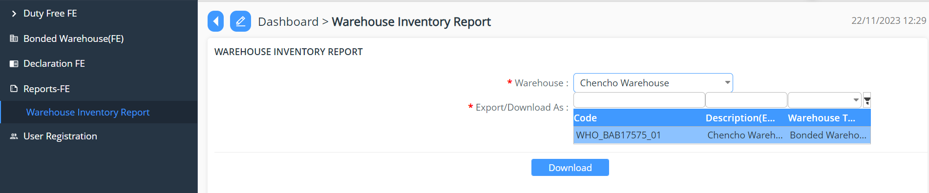
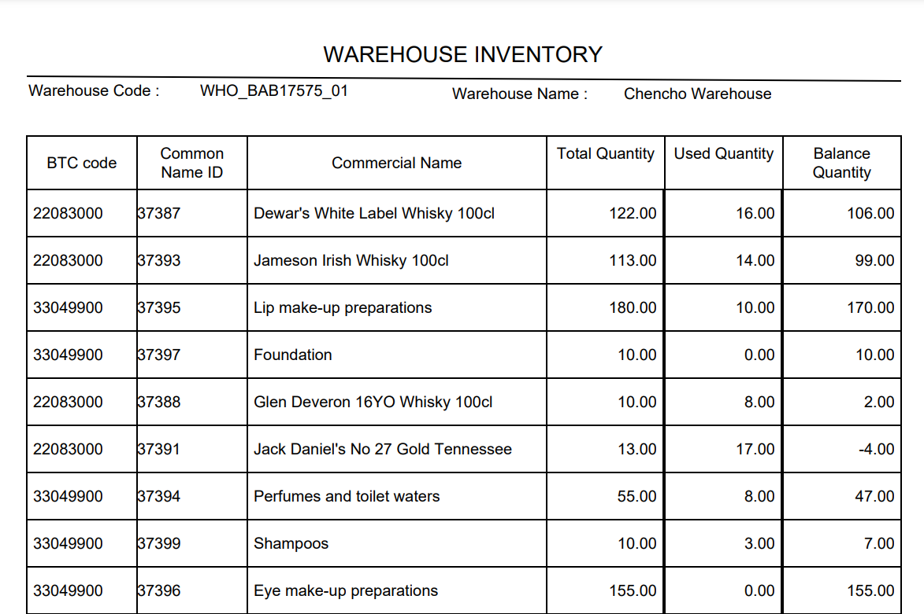

Duty Free Sales for Non quota Holder

Approve Declaration

- Go to Declaration menu and click on “Approve Declaration”.
- Search for the declaration reference number if the number is known/ the Custom user will be doing there due diligent but working on the day-to-day application received.
- The Custom user will then validate the declaration under each menu to validate the detail submitted by the user.
- Once the review is completed the focal will have the option to do the following to the declaration:

- Approve: the application is reviewed and approved
- Reject: the application gets rejected due to certain reasons; the reason will be then provided in remarks.
- Reject for amendment: due to certain missing details the application will be send back for amendment.
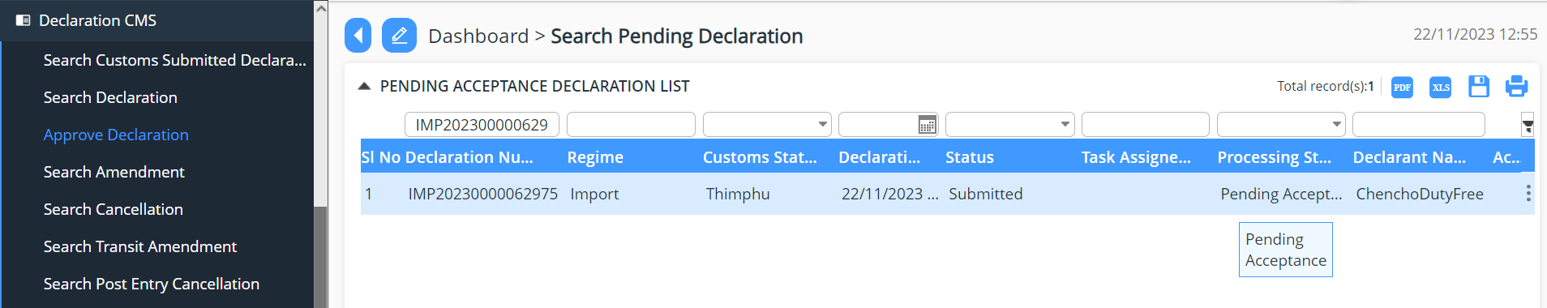
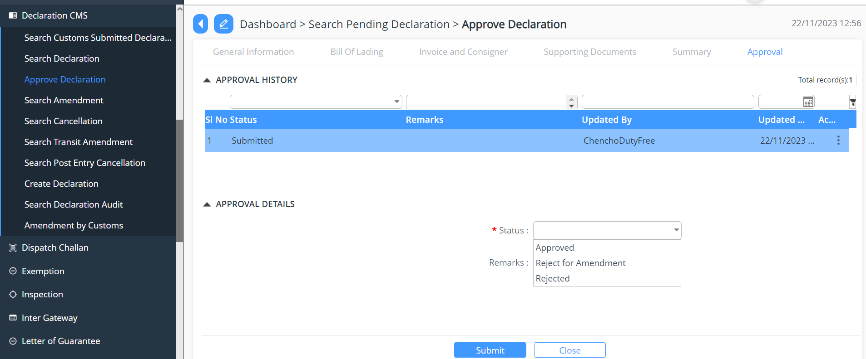

Payment
- Go to Payment
- Select the menu Pending Payment
- Select the declaration for which the payment receipt needs to be generated.
- Payment received and completed

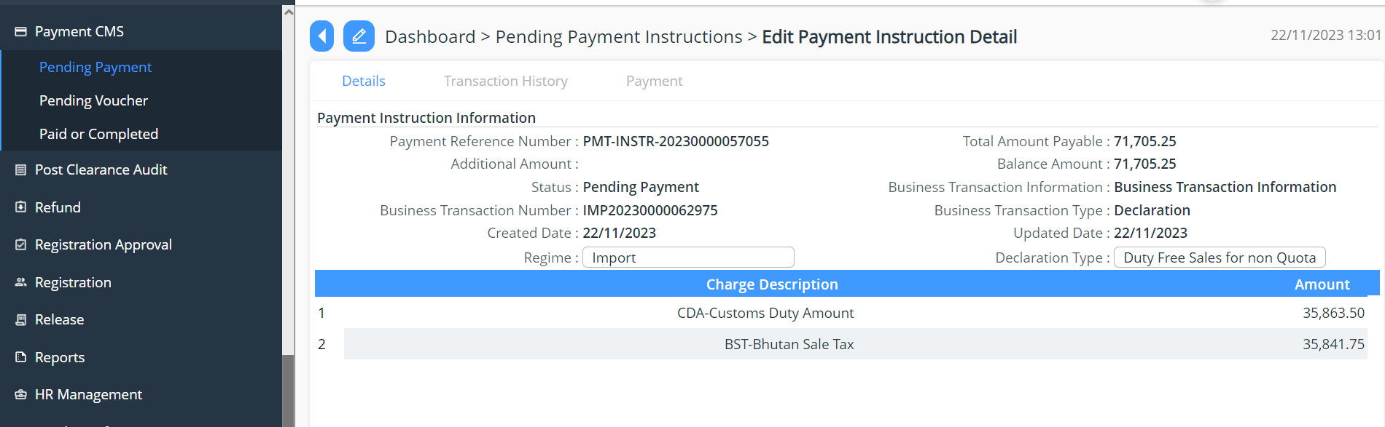
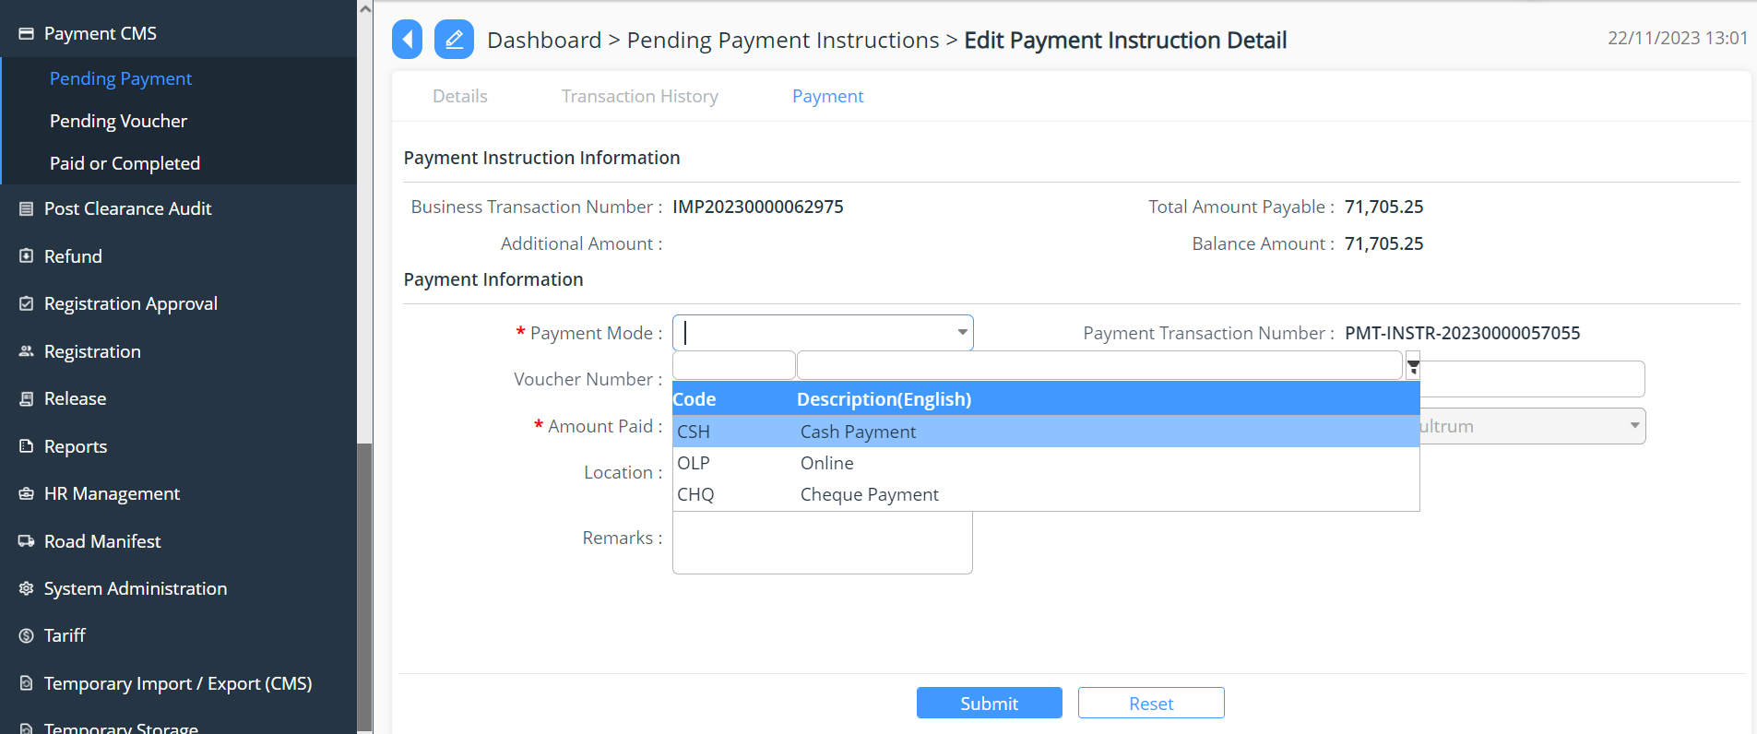
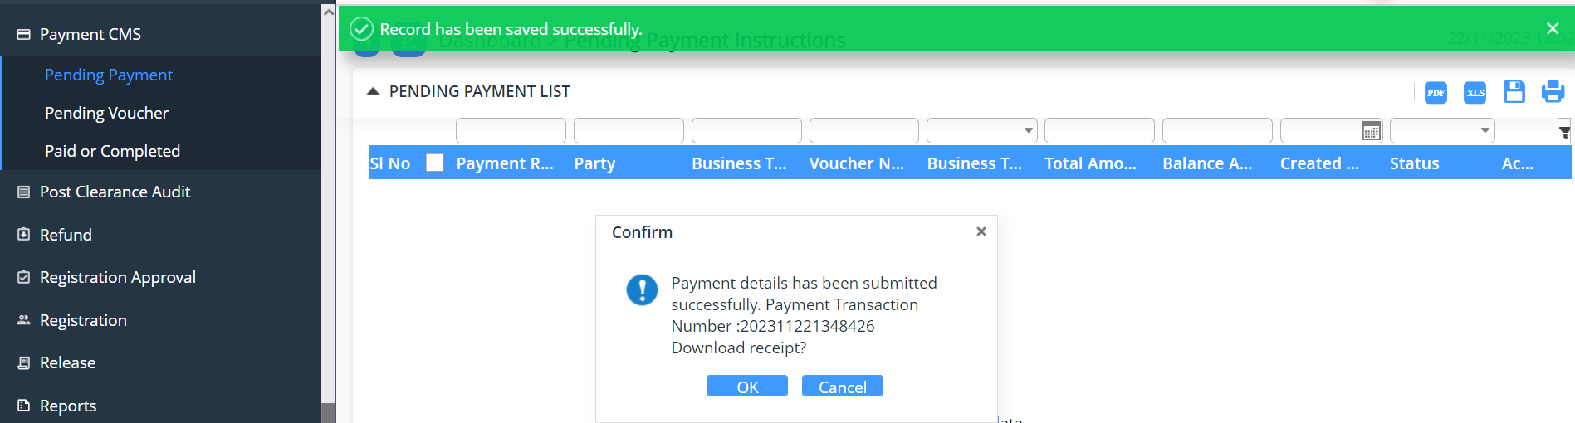

Valuation
- Go to Valuation
- Select the menu Pending Valuation List
- Select the declaration for valuation
- Provide the finding as per the requirement
- Update the declaration
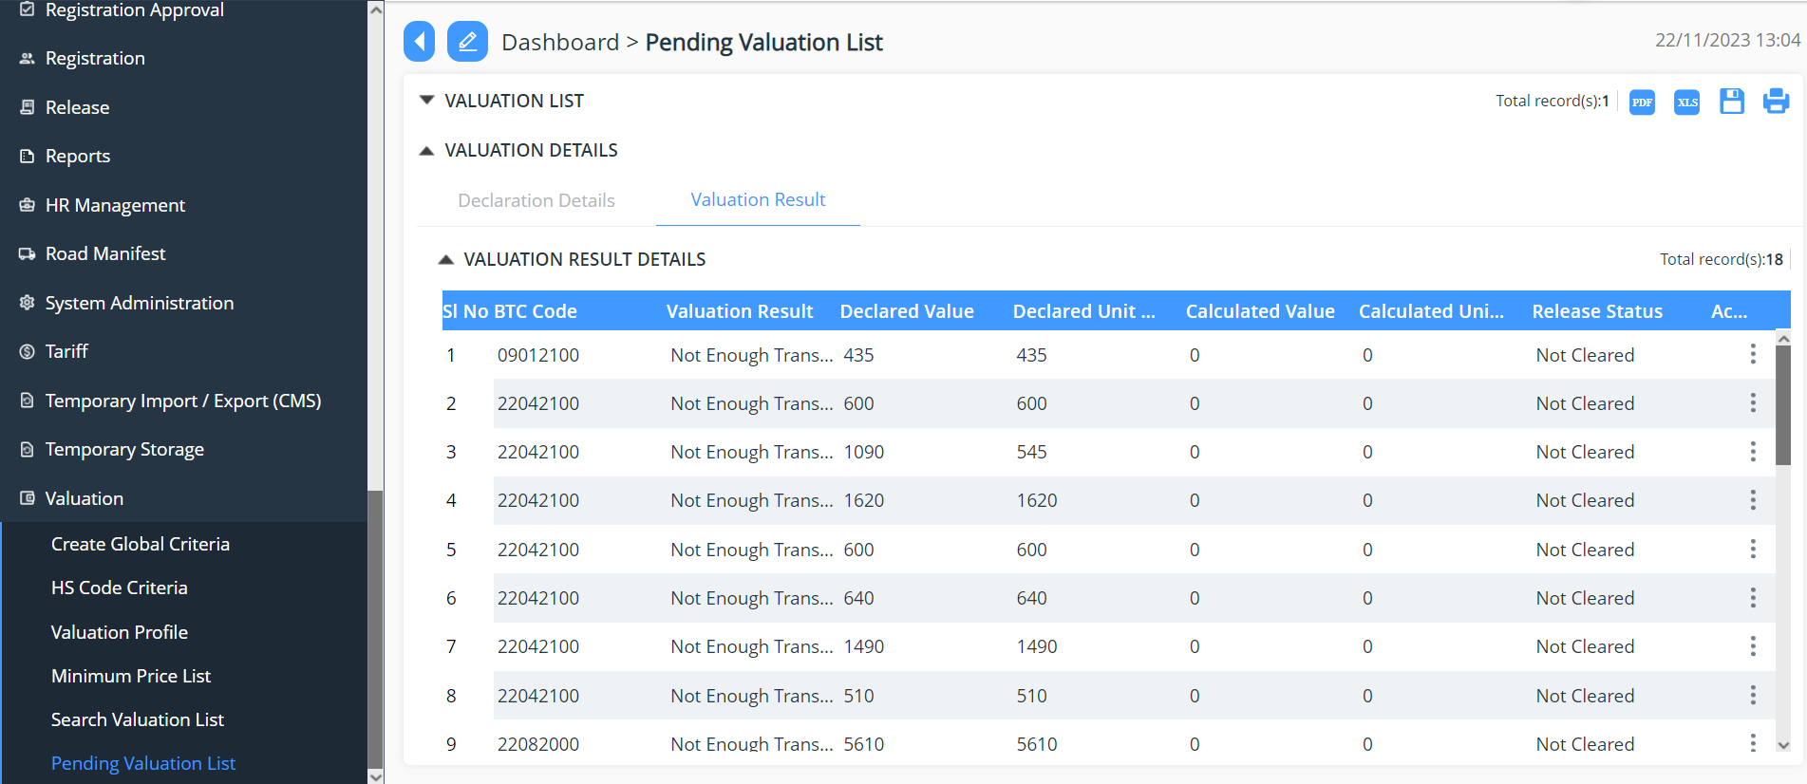
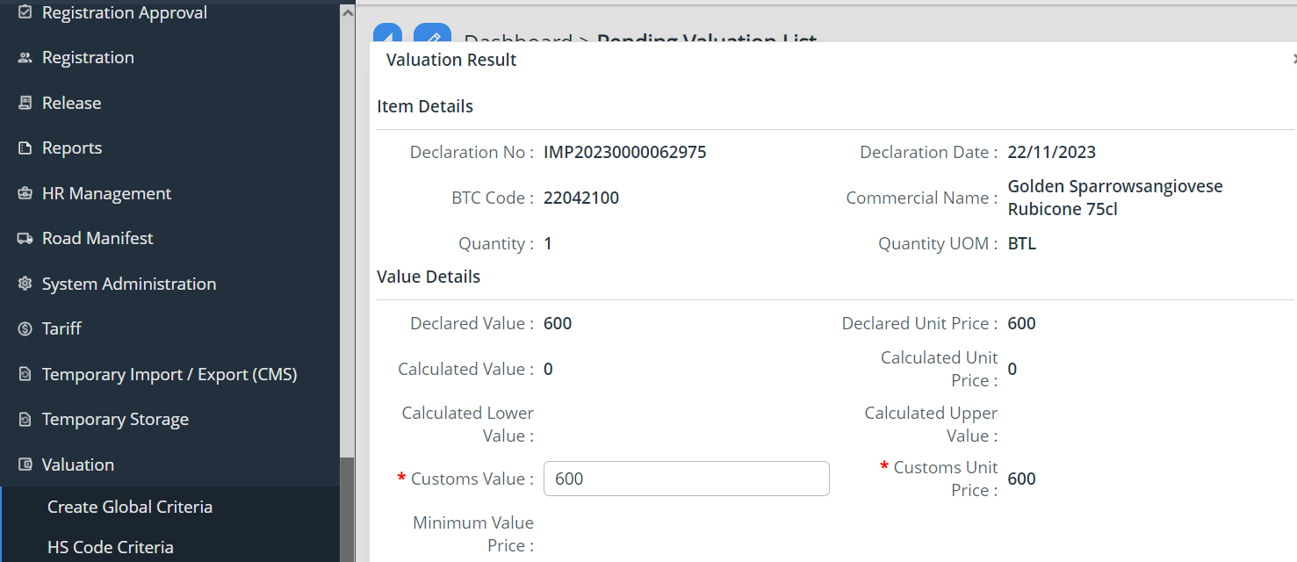
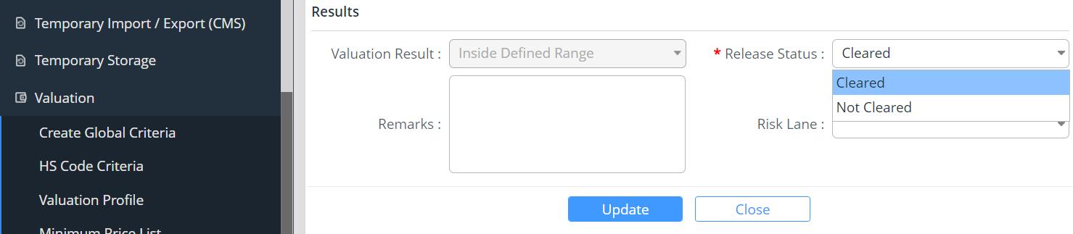

Release
- Go to Release
- Select the menu Release Order
- Select the declaration for release
- Choose the release order status from the drop down list
- Update the declaration
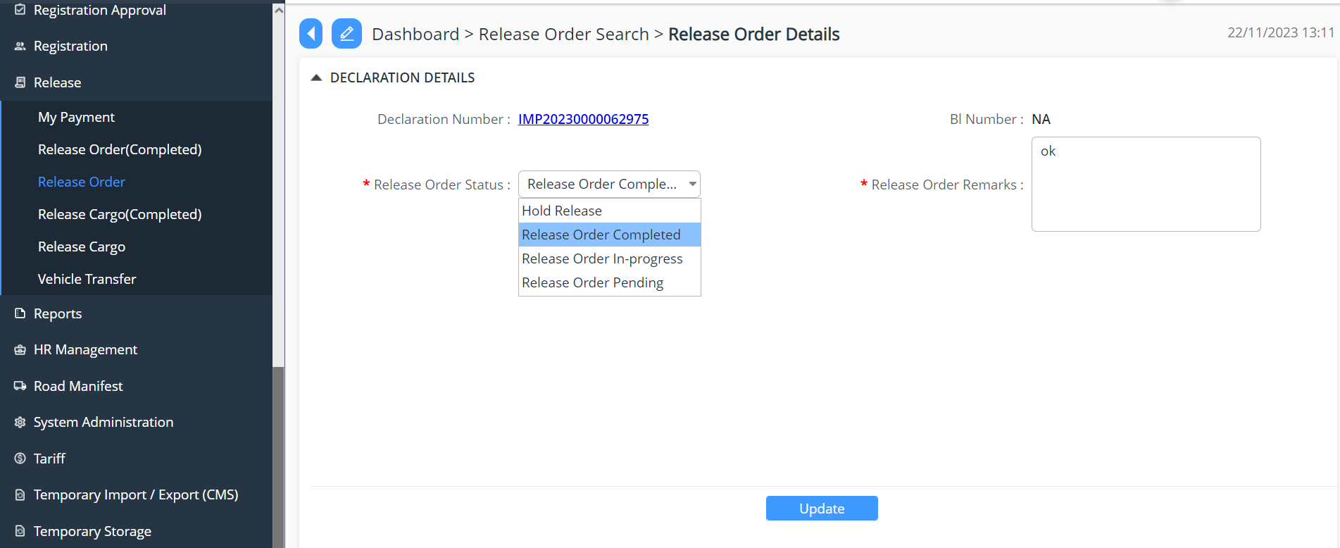

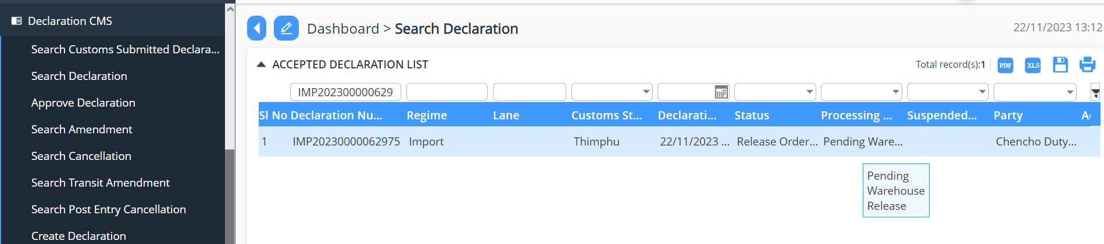

Warehouse Release
- Login as Warehouse Operator
- Release Duty Free goods

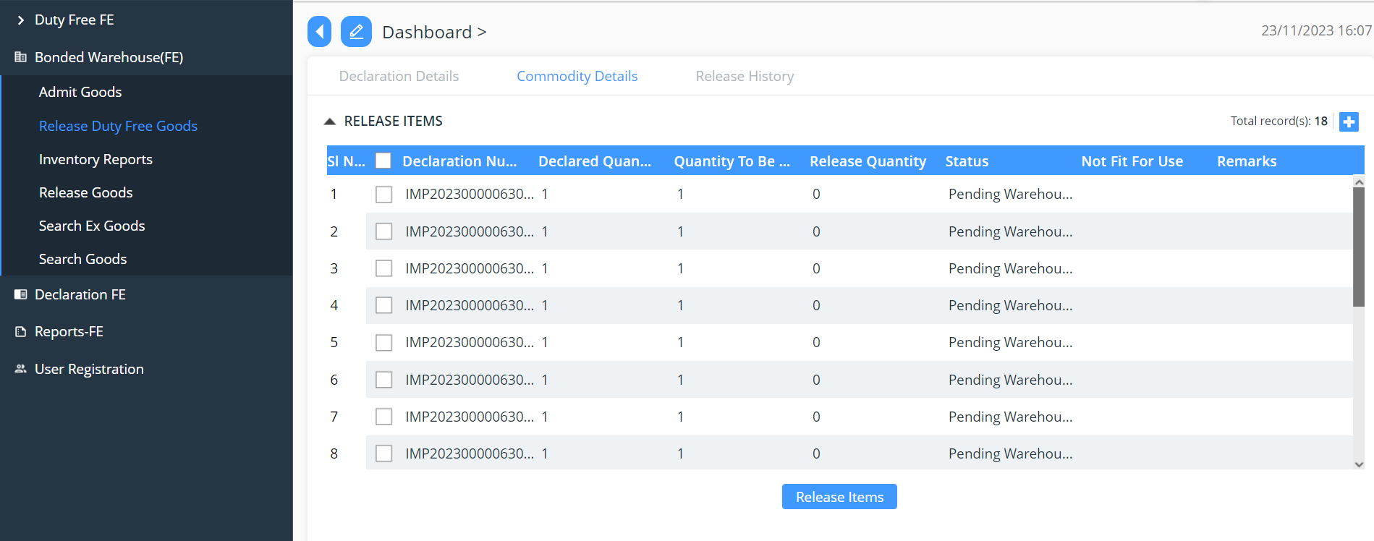
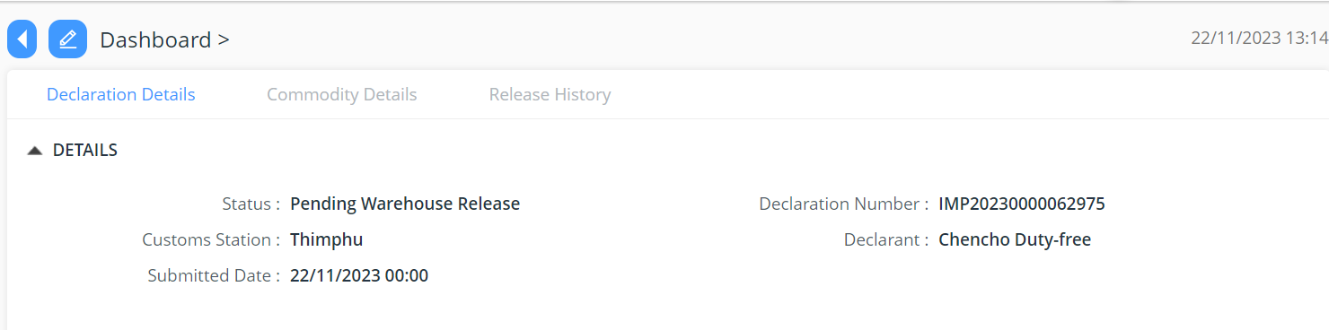
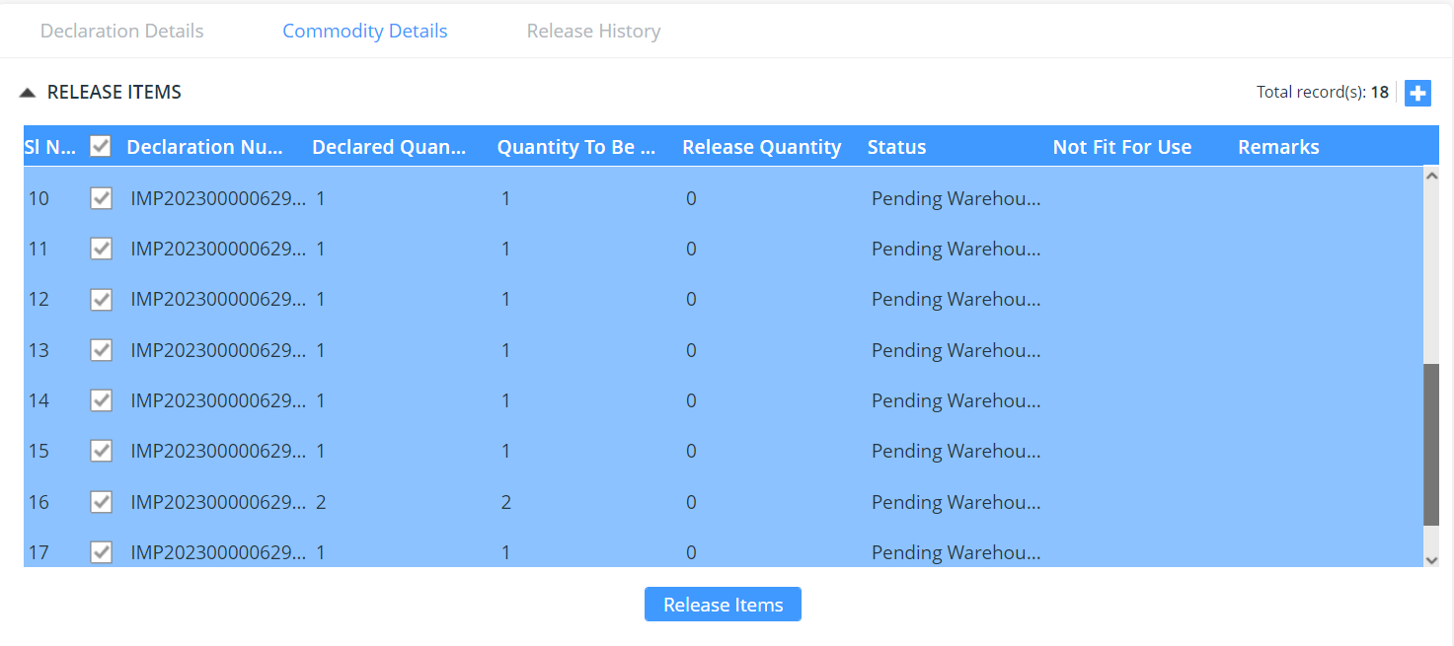
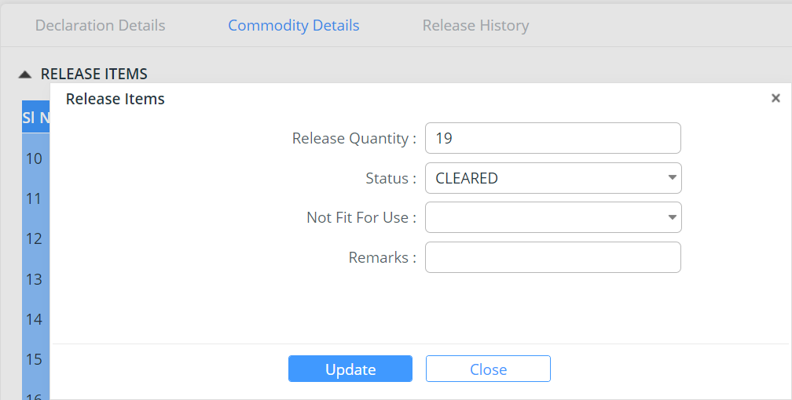
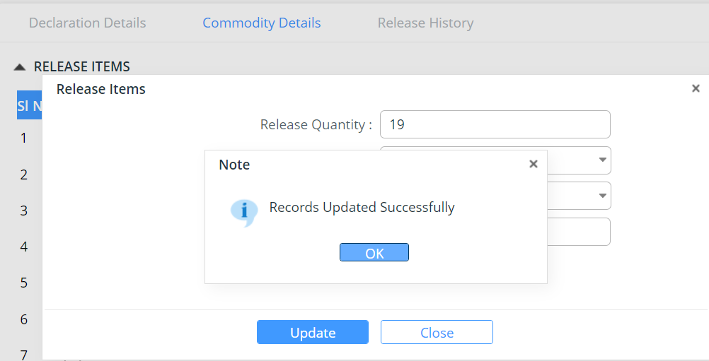
When we release goods from warehouse, system will automatically deduct qty based on how much we declare on declaration from stock.

Warehouse Inventory provides the details of the goods in the warehouse:
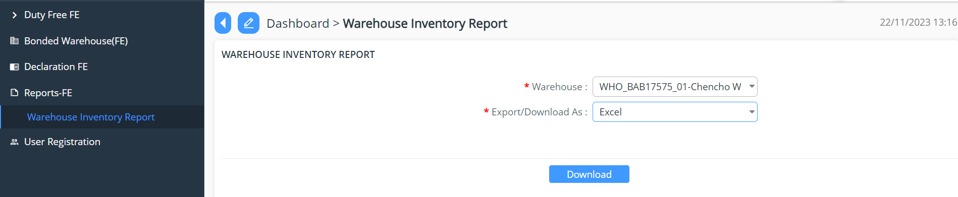
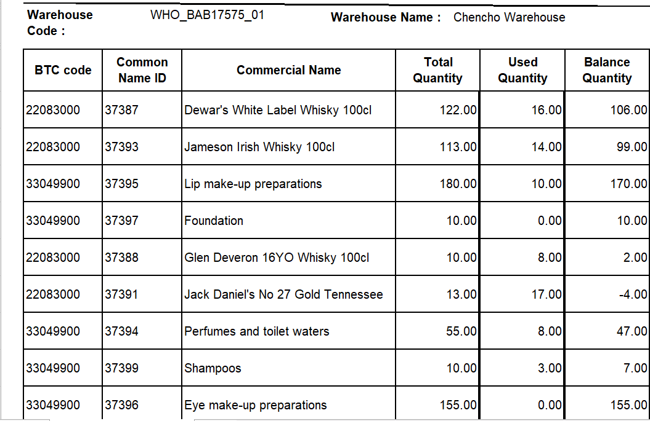

Duty Free Sales for Non quota Holder

Approve Declaration

- Go to Declaration menu and click on “Approve Declaration”.
- Search for the declaration reference number if the number is known/ the Custom user will be doing there due diligent but working on the day-to-day application received.
- The Custom user will then validate the declaration under each menu to validate the detail submitted by the Duty Free user.
- Once the review is completed the focal will have the option to do the following to the declaration:

- Approve: the application is reviewed and approved
On the approval of the declaration the quota balance gets deducted accordingly

- Reject: the application gets rejected due to certain reasons; the reason will be then provided in remarks.
- Reject for amendment: due to certain missing details the application will be send back for amendment.



Release
- Go to Release
- Select the menu Release Order
- Select the declaration for release
- Choose the release order status from the drop down list
- Update the declaration




Warehouse Release
- Login as Warehouse Operator
- Release Duty Free goods






When we release goods from warehouse, system will automatically deduct qty based on how much we declare on declaration from stock.

Warehouse Inventory provides the details of the goods in the warehouse:

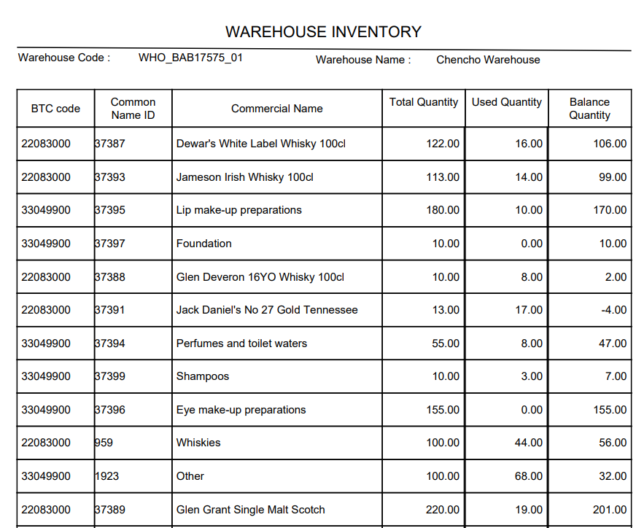

Duty Free Sales Airport

Approve Declaration

- Go to Declaration menu and click on “Approve Declaration”.
- Search for the declaration reference number if the number is known/ the Custom user will be doing there due diligent but working on the day-to-day application received.
- The Custom user will then validate the declaration under each menu to validate the detail submitted by the Duty Free user.
- Once the review is completed the focal will have the option to do the following to the declaration:
- Approve: the application is reviewed and approved
- Reject: the application gets rejected due to certain reasons; the reason will be then provided in remarks.
- Reject for amendment: due to certain missing details the application will be send back for amendment.
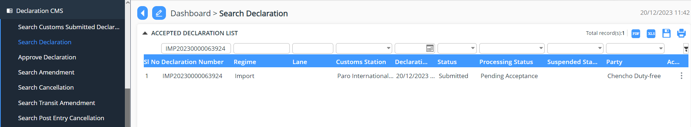
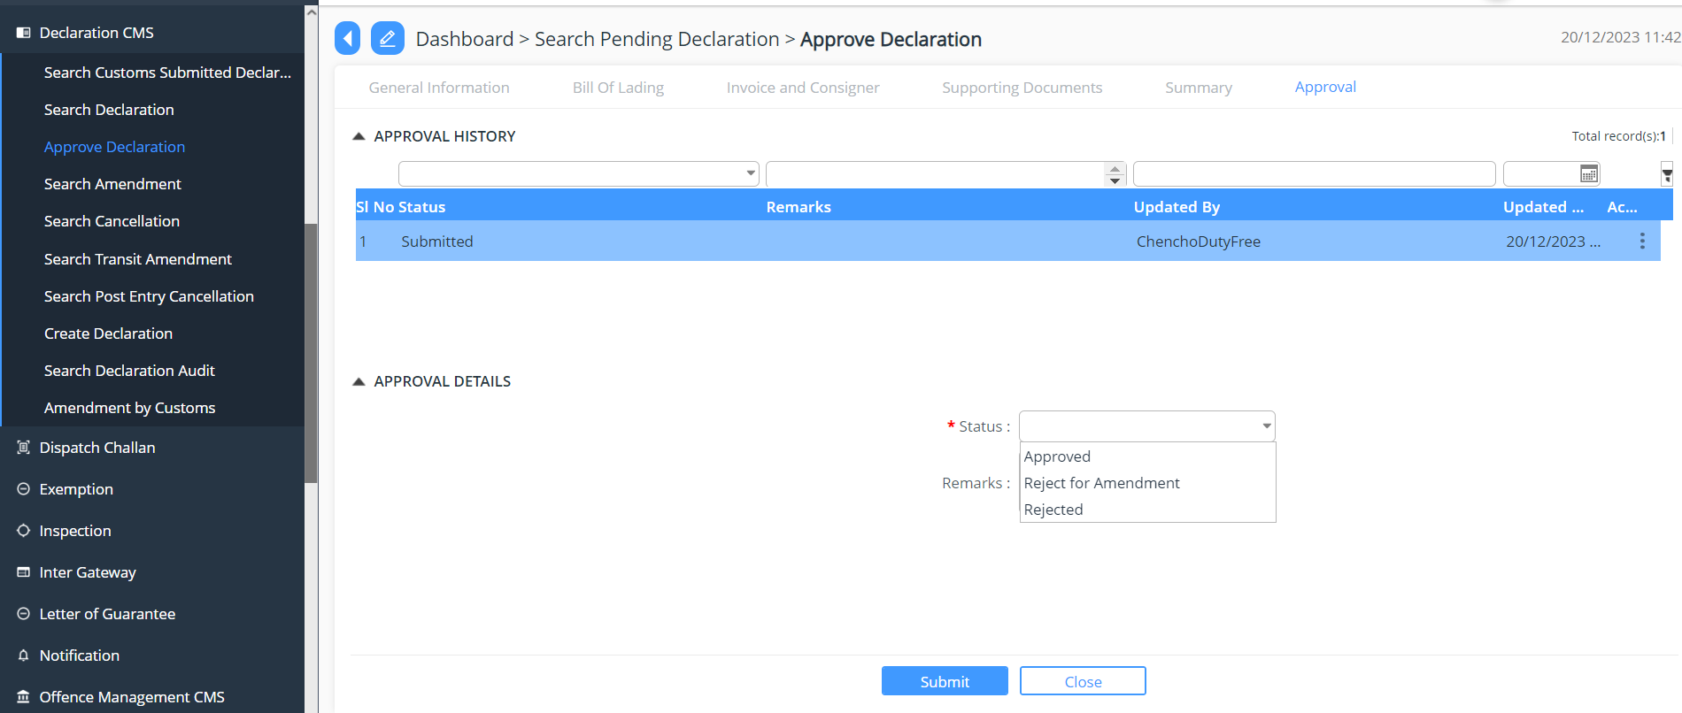

Release
- Go to Release
- Select the menu Release Order
- Select the declaration for release
- Choose the release order status from the drop down list
- Update the declaration
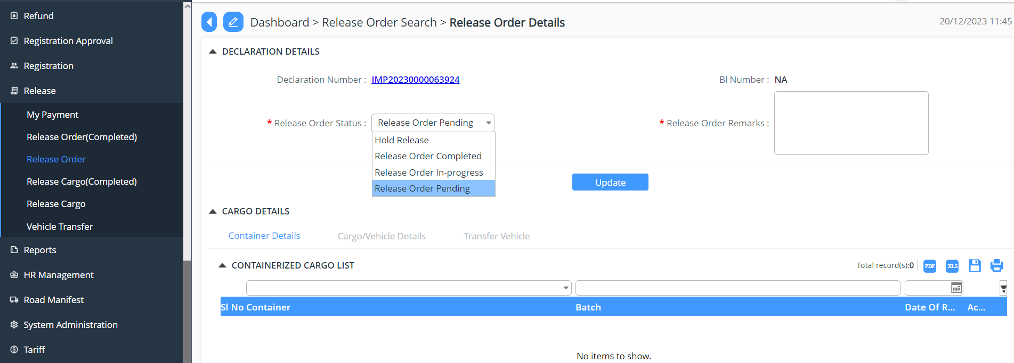

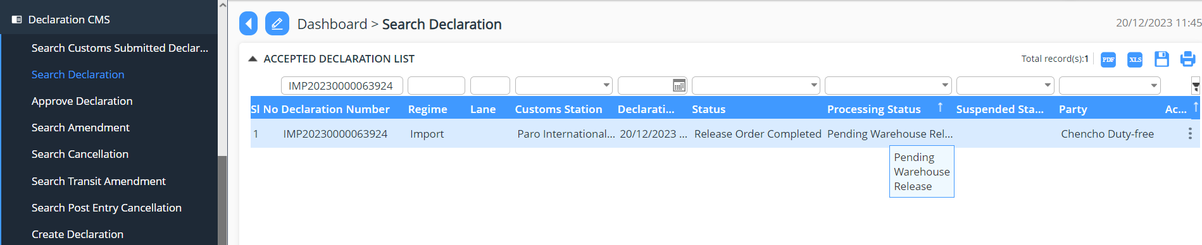

Warehouse Release
- Login as Warehouse Operator
- Release Duty Free goods
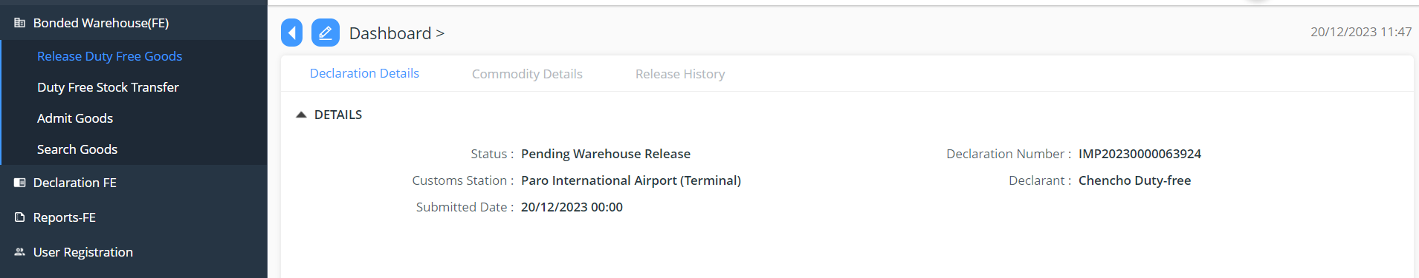

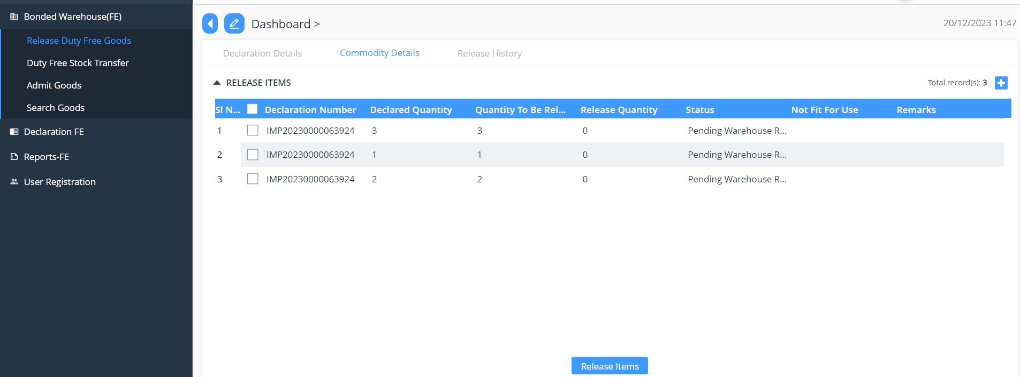
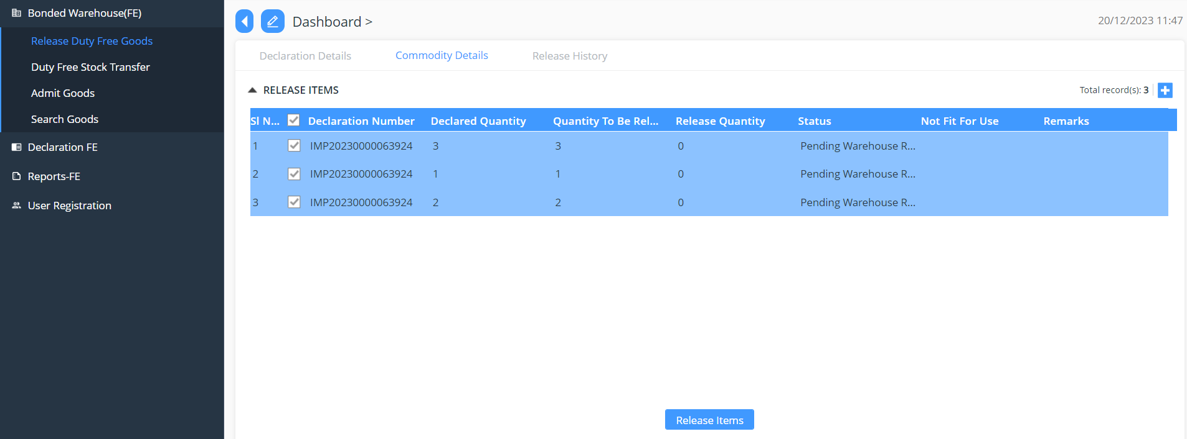

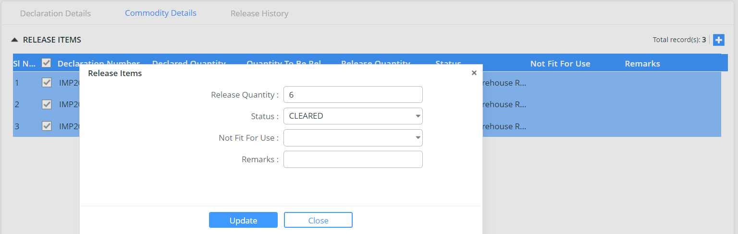

When we release goods from warehouse, system will automatically deduct qty based on how much we declare on declaration from stock.

Warehouse Inventory provides the details of the goods in the warehouse:

Before Release
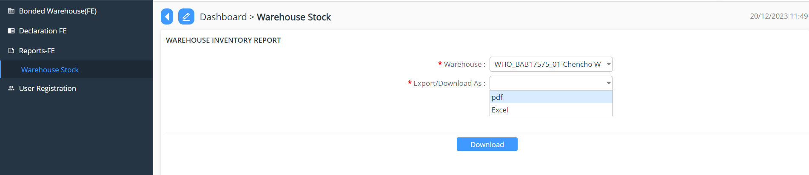
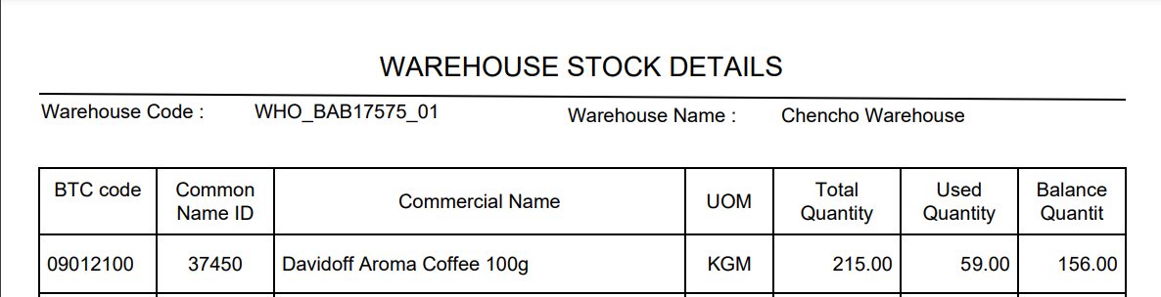

After Release

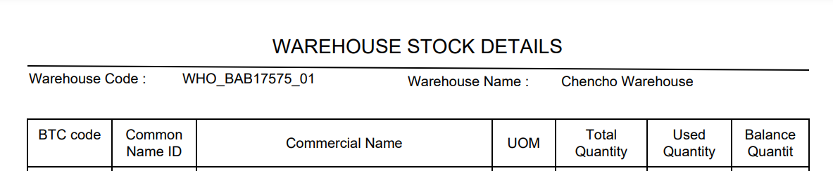

Duty Free Consumption on Board

Approve Declaration

- Go to Declaration menu and click on “Approve Declaration”.
- Search for the declaration reference number if the number is known/ the Custom user will be doing there due diligent but working on the day-to-day application received.
- The Custom user will then validate the declaration under each menu to validate the detail submitted by the Duty Free user.
- Once the review is completed the focal will have the option to do the following to the declaration:
- Approve: the application is reviewed and approved
- Reject: the application gets rejected due to certain reasons; the reason will be then provided in remarks.
- Reject for amendment: due to certain missing details the application will be send back for amendment.
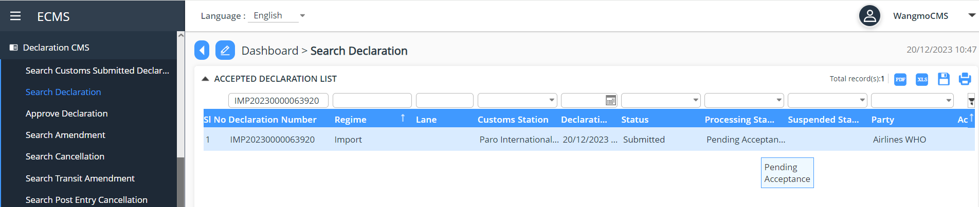
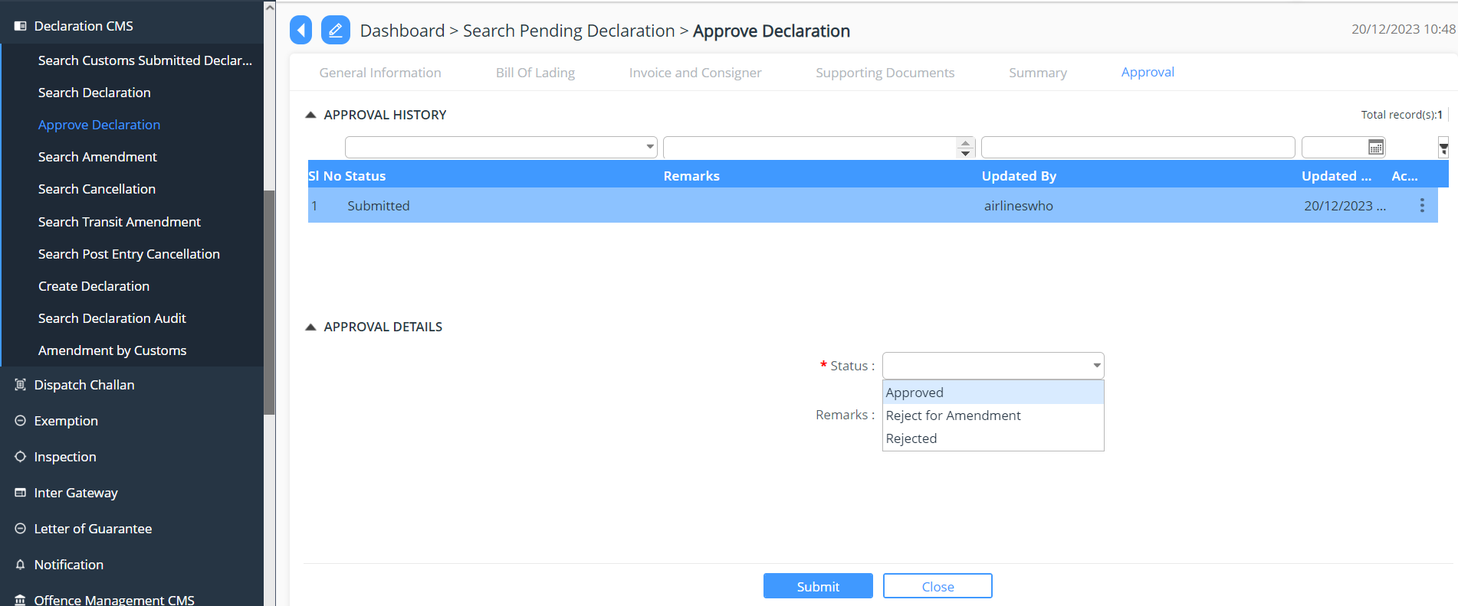

Release
- Go to Release
- Select the menu Release Order
- Select the declaration for release
- Choose the release order status from the drop down list
- Update the declaration
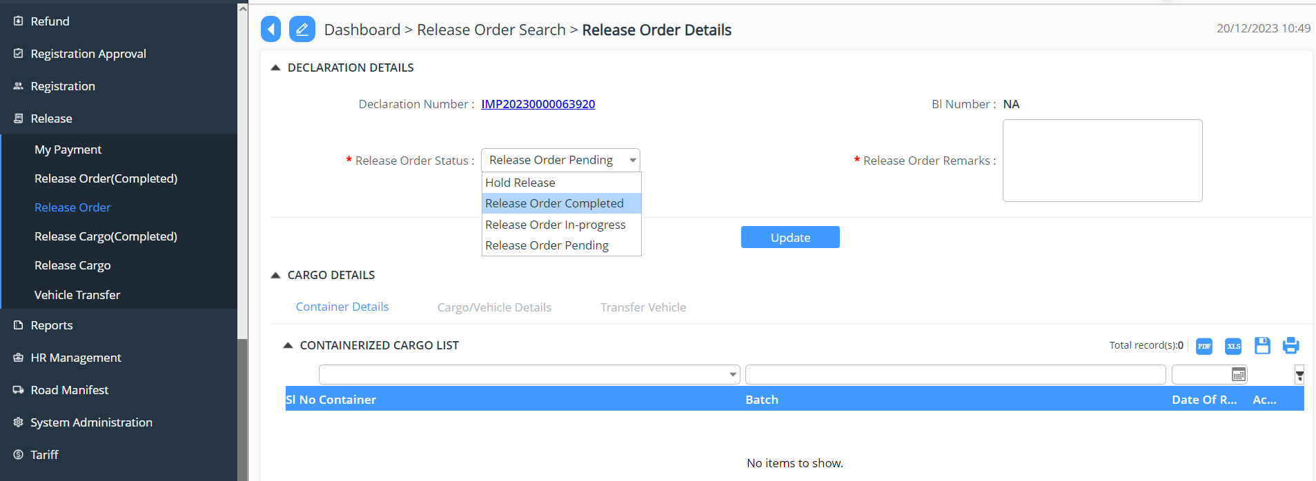
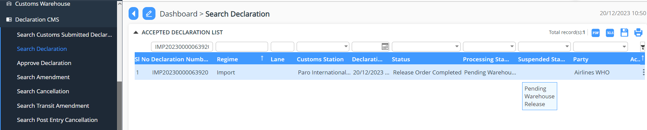

Warehouse Release
- Login as Airline Warehouse Operator
- Release Duty Free goods
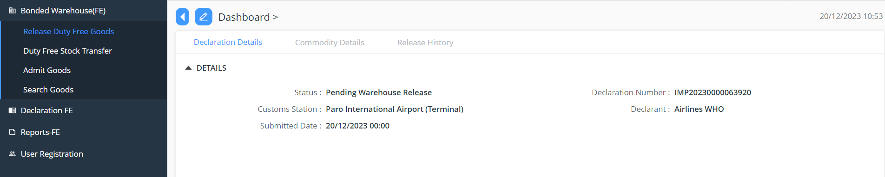

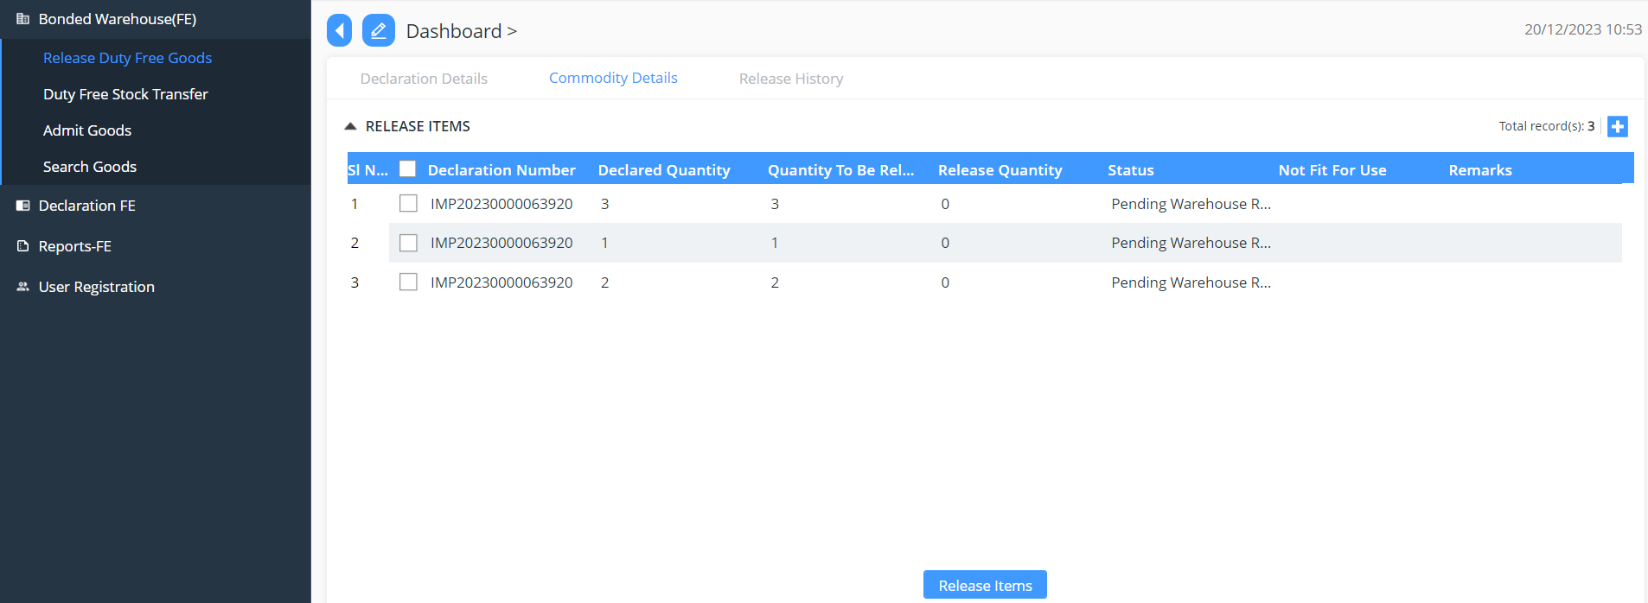




When we release goods from warehouse, system will automatically deduct qty based on how much we declare on declaration from stock.

Warehouse Inventory provides the details of the goods in the warehouse:

Before Release

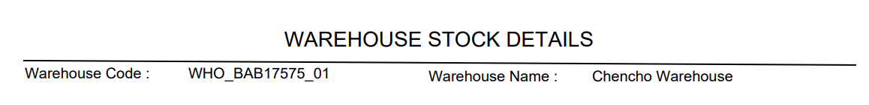
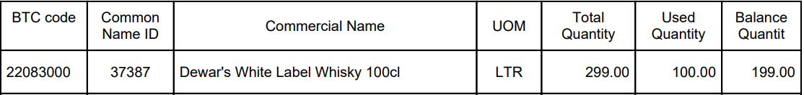

After Release

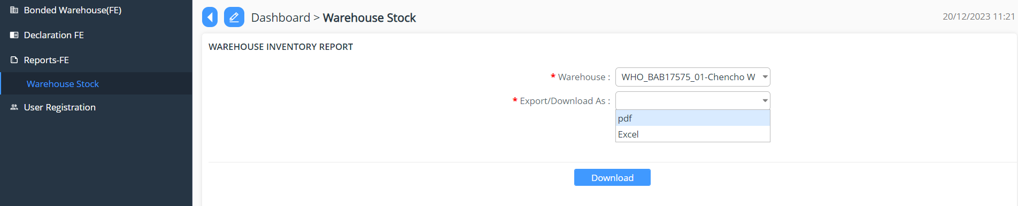


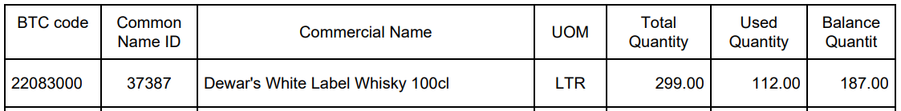

Duty Free Sales on Board

Approve Declaration

- Go to Declaration menu and click on “Approve Declaration”.
- Search for the declaration reference number if the number is known/ the Custom user will be doing there due diligent but working on the day-to-day application received.
- The Custom user will then validate the declaration under each menu to validate the detail submitted by the Duty Free user.
- Once the review is completed the focal will have the option to do the following to the declaration:
- Approve: the application is reviewed and approved
- Reject: the application gets rejected due to certain reasons; the reason will be then provided in remarks.
- Reject for amendment: due to certain missing details the application will be send back for amendment.



Release
- Go to Release
- Select the menu Release Order
- Select the declaration for release
- Choose the release order status from the drop down list
- Update the declaration



Warehouse Release
- Login as Airline Warehouse Operator
- Release Duty Free goods







When we release goods from warehouse, system will automatically deduct qty based on how much we declare on declaration from stock.

Warehouse Inventory provides the details of the goods in the warehouse:

Before Release




After Release




